How to Buy Wrestling Shoes for your Wrestler in 2021
If you're buying wrestling shoes for the first time or replacing an old pair, we’re here to help ensure you get the most from your new shoes.
- Size - Find the right fit
- Price - What's best for my budget?
- Color - There's a rainbow to choose from
- Style - Does it matter?
- Brand - Who's the best?

Size - Finding the right fit
The first step is to establish the size you need. Each manufacturer has different recommendations. For example, Asics recommends that you add a 1/2 size to your regular street shoe size for most of their shoes while Nike recommends between one half and one full size to your normal street shoe size. Please use the following size chart and appropriate recommendations.
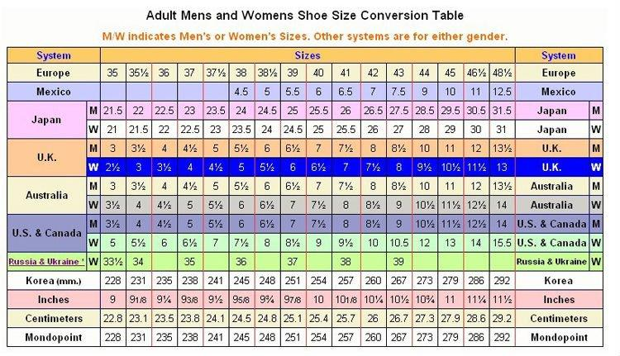
For younger wrestlers you should probably add a full size to their normal shoe size. This way the shoes will last longer, especially if your daughter or son is growing quickly. However, if your wrestler is an elite athlete, it's important that the shoes aren't too big. Most shoes will stretch after a couple of practices. If you find that the shoes you ordered are too tight, don't wear them to practice as we cannot allow returns on shoes that have been worn.
For those wrestlers with a wider foot, we recommend the Asics Snapdown 3 Wide wrestling shoes.

Price - What's best for my budget?
Next, you need to determine your budget. Most wrestling shoes range from $40 to well over $100. If you're not sure whether your son or daughter will stay in the sport long enough to get full value from the shoes, it's best to go with the lower cost shoe (especially if the wrestler is a rookie). If your budget is tight you can also buy a pair of used shoes from an older wrestler or even eBay. Generally, the more expensive shoes are the lightest and have the best grip.

Color - There's a rainbow to choose from
Once you've sorted your budget, you'll need to consider colors. Today’s top brands including Nike, Adidas, Asics, and Matman offer a wide variety of colors. The color you choose is entirely up to you. From the more traditional black & white to the patriotic red, white & blue to pink, bright orange & yellow, you’ll find the color that best suits your tastes or school colors.

Style - Does it matter?
The next step is to determine whether you want a split sole shoe or non-split sole. Most manufacturers including Nike, Asics and Adidas offer split sole wrestling shoes along with solid sole shoes. The split sole or single sole debate is entirely up to you. Generally, the split sole shoes cost more, are most comfortable and provide better traction on the mat.

Brand - Who's the best?
Finally, your last option is to choose the brand. Adidas, Nike, Asics & Matman have been manufacturing shoes for decades and provide great quality products. In many cases your wrestler will get 1-2 high school seasons out of these shoes. Elite wrestlers will likely get a good year from a pair of shoes depending on the amount of time they spend on the mat throughout the year. Obviously, like running shoes, the more they wrestle, the more often you'll need to replace them.

- 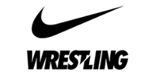
Nike Shoes
- 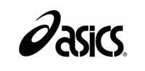
Asics Shoes
- 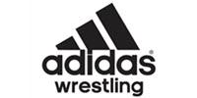
Adidas Shoes
- 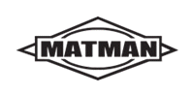
Matman Shoes

If you're still unsure of which shoe to buy, try asking those around you who have been wrestling for a while. Sometimes the best recommendation will come from someone you know.

